I am on the Seventh Cloud (Really!):


The fundamentals of double entry accounting have remained the same from Luca Pacioli’s time but the tools to keep the books using these fundamentals have changed over time. Paper and pencil lasted for centuries and with main frame computers for corporations in late 1960s and then with IBM PC in early 1980s came Visicalc software that brought accounting professional to the PCs followed by various accounting and tax software.
These software approach “automated” the double entry and virtually eliminated the paper journals and ledgers making the bookkeeping process smooth with fewer chances of human errors of calculations and posting that is inherent in paper and pencil environment with green shade!
Even in this environment there were some drastic changes (and we all went kicking and screaming – change is hard!). First we had single tasking DOS – command line and keyboard driven access. This was followed by multitasking and mouse driven graphical access of Windows. Many felt that DOS was faster and were not willing to move to Windows but they did move on and found it better!
In 1990s Intuit expanded its very successful Quicken ® personal finance (check book writer) software and introduced QuickBooks ® bookkeeping software for small business and it captured the major market share of the small businesses which was almost non-existent. SMB were typically “shoebox” clients and relied on their bookkeeper/accountant to do bookkeeping but now they can do majority of the work – the slogan was “fire your accountant” – of course one could not do that but felt that they had better control now. It became the major player and captured almost 90% of the SMB market. I will use more of QB example vs. others since that is the most prevalent environment today.
However it also created a whole new industry of independent bookkeepers to assist the small business owners who did not know accounting fundamentals and were using powerful accounting software and making errors –a simple example is a purchase of car would show up as an expense vs. as an asset!
Along with these user generated errors the desktop accounting software environment, as much as it automated the double entry system and eliminated the paper and pencil approach, also brought certain inefficiencies in the bookkeeping process as listed below:
• One had to buy additional license to use the software on more than one PC or to allow access for more than certain number of users.
• One had to be at the PC on which the software was installed so one had to keep one copy of the license at the office, at home and the client had to have her own licensed copy on her PC(s).
• This meant that any changes/updates to the software had to be installed on these PCs which could be time consuming (akin to changing time on all the clocks in every rooms, VCRs, wrist watch etc. when the Daylight Time changes - twice a year affair!)
• And every year a new version had to be installed to take advantage of the new functionality but the files generated from these new versions could not be read by older versions and the client, generally, would not upgrade every year meaning bookkeeper had to keep copies of the older versions of past years as well and make sure that they were updated as new patches/ updates came along.
• The work file being on the client’s computer meant that it had to be sent to the bookkeeper and after making the changes had to be sent back to the client.
- The time lack to get correction and sent back to the client gave another possible chance for more changes and errors by the client plus
- The size of the file, over time, became too large to be sent by normal email.
- This, at times, necessitated the bookkeeper to travel to the client’s office to do the work resulting in non-productive time and extra cost to the client.
• This also limited the market access to those clients who were within short driving distance and if the client moved then one lost the client.
• To avoid this time lag and the travel time to the client’s office came in the additional cost remote desktop access software allowing the bookkeeper to log into the client’s PC.
- But while the bookkeeper was working in the client’s PC the client could not use the PC meaning the bookkeeper had to do the work at odd hours!
- Of course one had to make sure to have proper security like proper firewall, antivirus and malware etc. software that would not erase the work file.
- And one had to make sure to have a backup in case of such a disaster!
- And the most annoying part was that the client had access to a powerful accounting software but for most part would not know the accounting fundamentals and would invariably make mistakes resulting in extra time to fix these client generated errors. As mentioned before, simple example is a purchase of car would show up as an expense vs. as an asset!
- More frustration came due to time lag between the client mailing the file to the bookkeeper and bookkeeper making changes and sending the file back to the client while the client had made more changes and possibly some new errors! So possibly more use of remote access software.
The key is that in this environment the client is in the driver’s seat and the bookkeeper has to work with all the beauty and warts of this environment because the client bought, say, QuickBooks software and now expected the bookkeeper to use the same.
People had no alternative to these inherent inefficiencies in the desktop environment and we tolerated and kept finding ways to deal with them as effective as it was possible but they were impacting the productivity none-the-less until the Internet became commercially available (one more change!)
Though the Internet was around since late 1960s in the armed forces and universities it came to the commercial age in 1990s. This allowed even a small Part Time bookkeeper working from the kitchen table to be known by the entire world to see what services are offered and this created a level playing field since one does not have to see the brick and mortar office of the bookkeeper and yet know everything (and more) from the bookkeeper’s website. And Web 1.0 was born!
Today the software can reside on commercial server farms that are accessible from anywhere and at anytime. One of the early examples of this was the Hotmail – mail software hosted on remote server which could be accessed anytime and from anywhere and no need to have office email server and allowed masses to have access to the email communication with no cost of a mail server. Just a PC and even a dial-up connection to the Internet was enough to communicate with anyone around the world who had the same environment of a PC and the Internet access.
The Internet was called a cloud (since it was always shown as a cloud in the network diagram because truly no one owns the backbone of the Internet as a whole). This new environment of having the software installed on some remote computer managed by someone else that can be accessed through the cloud (the Internet) came to known as the Cloud computing. This started to change this desktop paradigm and the some of the above inherent bookkeeping process inefficiencies. Naturally the accounting desktop software went on these servers as well which allowed both the bookkeeper and the client an access from anywhere and anytime. This enabled a market reach beyond the neighborhood in the driving distance. A popular option is Hosted QuickBooks service which has the same desktop version of QuickBooks (with its beauty & warts) on a server in the cloud.
A Hosted QB environment can vary from $450-$700/year+ per user depending on the service provider, hosting plan and storage needs. Plus the license fee of the software that can range from $240 to $400 for, say, QB Pro to QB Premier (though one may be able to get discounts at Staples etc.). Similar pricing is for Hosted PeachTree ® environment.
Though this allowed the access from anywhere anytime and minimized the files going back and forth it had two basic issues: 1) The Internet was slow and 2) its availability was not universal. Moreover the other inefficiencies listed above still remained - be it versions, backward compatibility, client generated errors etc. because this was still the same desktop software but now housed on some remote computer – it was not changed at all. It carried many of beauty and warts (such as licensing) of the desktop environment.
In late 90s and early 2000 a whole new generation of software truly designed for the web environment came in the market. These were designed from grounds up vs. just taking the desktop software and put it on the server.

This new paradigm of software designed for the web allowed true collaboration between people in real time. The whole collaborative aspect of the Internet came to be known as Web 2.0. Facebook, Twitter, Linked-In etc. are just few examples of this aspect.
Some established desktop accounting software vendors grabbed this new paradigm to eliminate the bookkeeping process inefficiencies in the desktop environment. One of them was MicroVision®. It restructured and created new company called AccountantsWorld ®to offer Web 2.0 based collaborative accounting solutions. These types of solutions are called SaaS (Software as a Service) and this new computing environment came to be known as the Web based Computing (vs. Cloud Computing). There were others, like NetSuite®, but they were geared for large enterprises and large CPA firms vs. solo and small accounting firms. In recent years Intuit also has created an online version of QuickBooks but it has limited functionality and is geared for simpler business that needs the access from anywhere and anytime. I am sure that will change over time. Its pricing can be $25/month for 3 users to $40/month for 5 users ($300-$480/year), though the list of features compared to the desktop version are less one does get flexibility of anytime, anywhere in SaaS environment.
In this new Web 2.0 paradigm the software resides on the server and everyone gets the same set/subset of the functionality eliminating all versions and updates! When there is an update to the functionality there is no download and install of the new changes. The change is made on the software at the server – just one place – and everyone now has the latest version (no more changing of the time on clocks, VCRS, wristwatches, car clock etc. the twice a year hassle of the Day Light Savings Time change). And in true collaborative environment one gets whole new set of opportunities to customize the service.
Accounting Relief ® a SaaS solution from AccountantsWorld gutted the entire desktop based bookkeeping process to eliminate some of the steps like files going back and forth, versions, updates etc. to create a seamless collaborative accounting process that saves time and virtually eliminates the client generated errors.
There is no problem of backward compatibility of files since everyone has the same version. Of course the access from anywhere and anytime eliminates the travel but there is no need of extra cost of remote computer access software to the client’s PC and no need for odd hours of access. And there are no more files going back and forth!
Look below at typical 12 steps workflow in a Desktop environment to complete a bookkeeping process with the client (courtesy of Dr. Chandra Bhansali, President of AccountantsWorld). 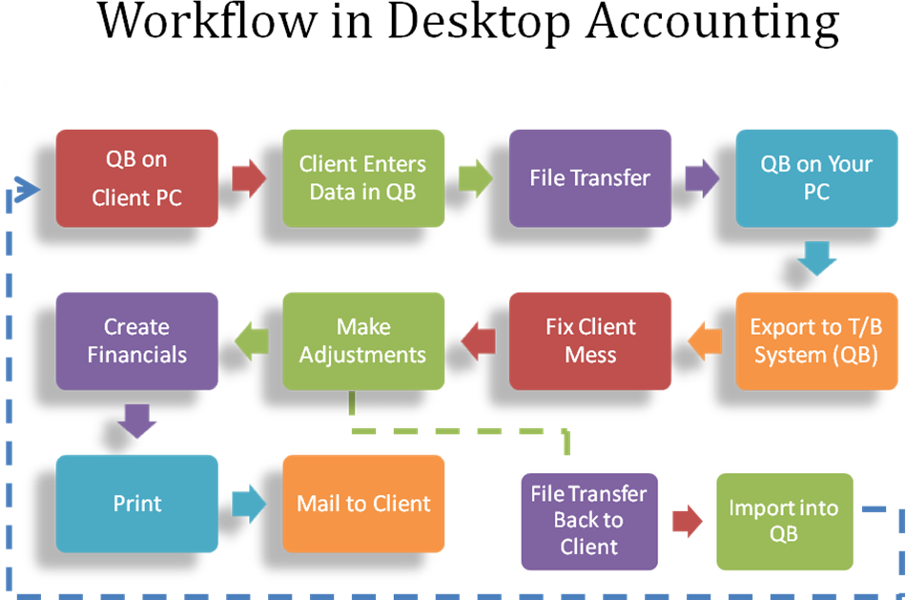
In a true collaborative web 2.0 based Accounting service like Accounting Relief from AccountantsWorld eliminates 8 of the 12 steps as shown below.
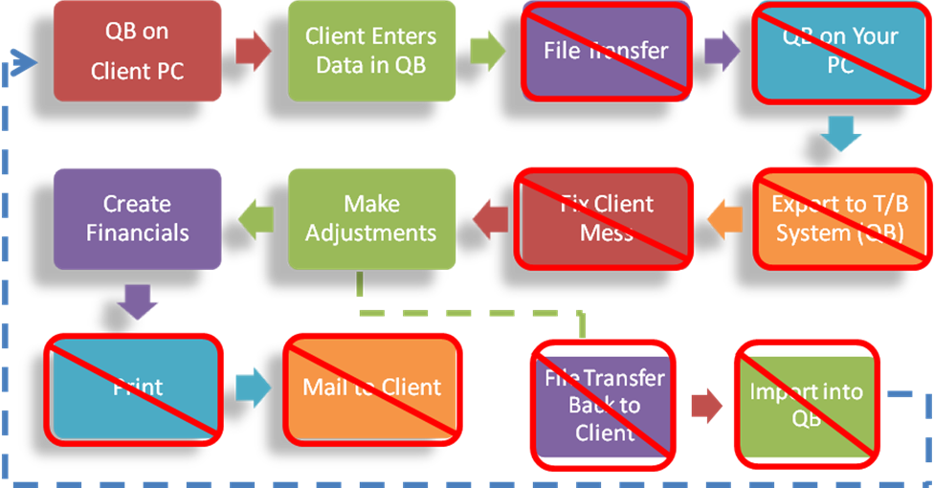
The resulting Web based computing service now has a very streamlined process as shown below.
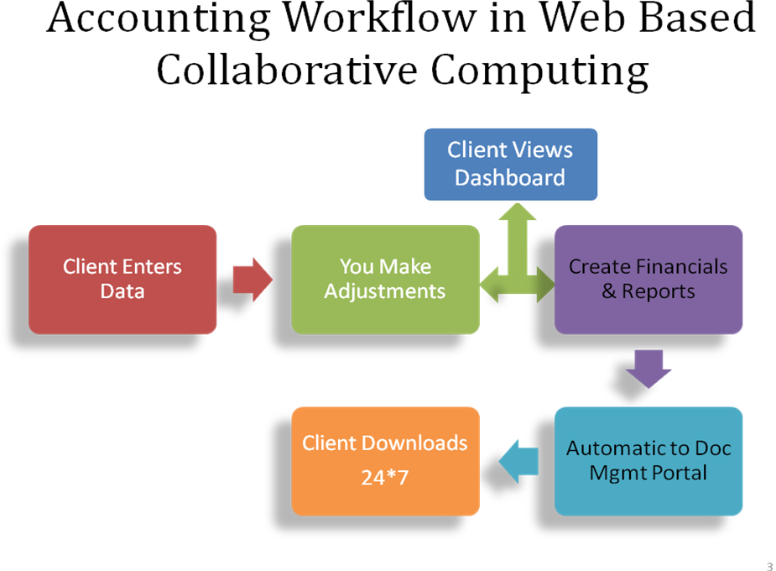
This streamline process now does the same work in less time making the bookkeeper and the client to be productive and can work independently and still can have synchronized work files available anytime and from anywhere. The bookkeeper can see (in real time) changes made by the client with no lag due to files going back & forth.
This extra time can now allow the bookkeeper to take on more clients and even offer some value added services that was not possible due to the time constraints!
This process simplification saves time but how can one minimize client generated errors in Web 2.0 environment? The root causes of these errors are: 1) Lack of accounting fundamentals (and one should not expect the client to have that – they have to run the business) and 2) having an access to the powerful and all functionality of the desktop software when they may need simply to update the customer/vendor info and check writing and may be invoice generation. If the client has the knowledge or a person on the staff with this knowledge then one can give higher level of access also like reconciliation but not the Trial Balance etc. This kind of selective access is generally not possible in the current desktop software.
However SaaS services like Accounting Relief does allow that level of granular access control by the client and creating many “versions” of the application that is geared to the capabilities of the client and no more. No sense of giving the client access to Chart of Accounts (COA) when they do not have solid accounting fundamentals! This level of access control AND the ability to work collaboratively with the client – meaning as simple as seeing exactly the view that the client has so one can catch the error as it is being made, if needed changes the whole paradigm of current desktop accounting process.
Look below at the various levels (and subsets) of access one can configure for the client to see in Accounting Relief. These settings let you control the activities you want your client to perform when using Accounting Relief.
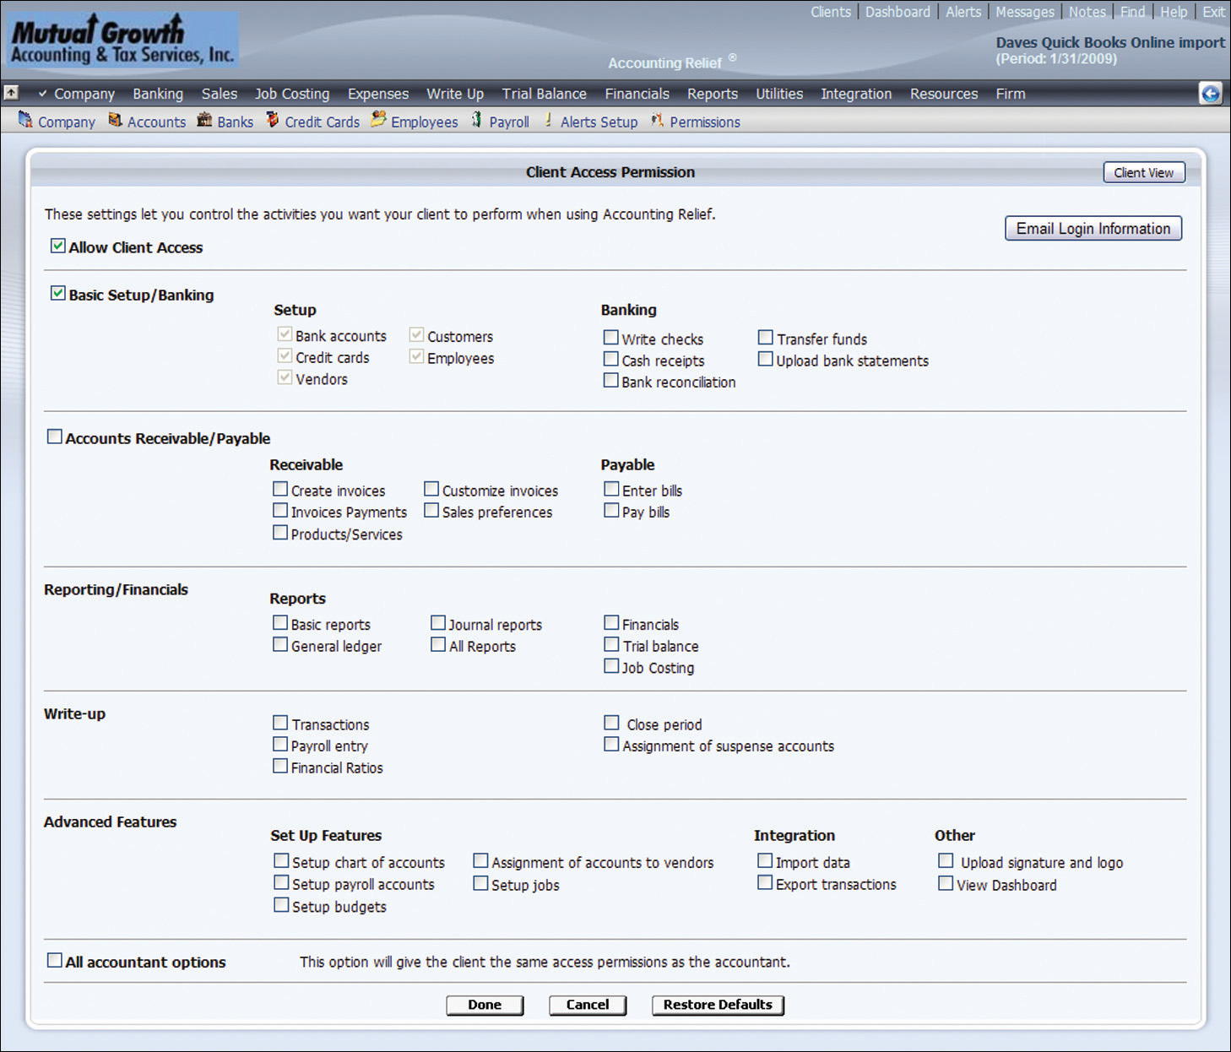
This whole streamlined, time saving process now puts the accountant/bookkeeper in the driver’s seat! You are choosing the environment and the software capability based on the client’s accounting knowledge and not the other way around.
Apart from this flexible collaboration and granular level of access security, it does have features like Write Up and Trial Balance, drill down from Trial Balance and financials for audit and review, thirty financial ratios, , A/R, A/P, sales, Expense, Retained Earning/ partner’s capital, Job Costing, consolidated reports, inventory, document attachment to a given transaction making audit and review an easier tasketc.
And it seamlessly integrates with its other Web Based SaaS tools like Payroll Relief ® - an award winning web based collaborative payroll SaaS, Website Relief ® , Directory listing to be found from major search engines, CyberCabinet ® - a web based document storage and exchange with the clients where clients can upload their bank statements etc. and accountant can post clients financials – no mail going back & forth, Practice Relief® - a time and billing/invoicing SaaS for complete 360 view of your profitability of your staff, services and clients. Seamless integration means no dual entry of the data – it can flow from one to other automatically. And more.
How does price for such a solution compare with desktop or hosted environment? A Hosted QB environment, as noted earlier, can range from $450-$700/year+ per user depending on the service provider, hosting plan and storage needs. Plus the license fee of the software that can range from $240 to $400 for QB Pro to QB Premier (though one may be able to get discounts at Staples etc.). Typically Accounting Relief SaaS cost $990/year for unlimited user license plus $10/month for client to access his/her data. And I do not have to maintain various years’ versions on my desktop. Clearly the Total Cost of Ownership (TCO) when both the accountant and clients cost are taken into account, the Accounting Relief SaaS is cheaper and better solution.
One issue that pops up frequently is that of security and privacy in Internet based environment. Some of these are behavioral issues also. All of SaaS applications use SSL (Secure Socket Layer) access meaning you have to have the web address as https and not http, with that you get minimum of 128 bit encryptions (like banks use) or higher. Today, one possibly does not think twice about doing online shopping with their credit card or do online banking but hesitate with their accounting data!
In reality there is far better security and safety in SaaS environment. Very rarely you will come across someone using an encrypted PC. Many do not run the right antivirus, malware software and even use service like torrent and do unsafe surfing that brings in virus that can not only wipe out the entire disk but can also install some stealth key logger software which captures (and sends to the hacker) all of your key board strokes including your login, password and credit card information. As a fact, relatively few, people use strong passwords and end up using the same password for all the online services (or worse – write that on a post-it and stick it on the monitor – not you, of course!) so a single compromised password will open all of the access! And how many of the clients take multi level of back-up of the data on external hard drive or online vaults and/or take disk images (hopefully all of you do that)?
A true commercial SaaS provider uses an industrial grade data center with duplicate servers with different electric power grids, extra power generators and cooling, retina and fingerprint scans to enter the locked cage in which the server resides. They have strong antivirus, malware etc. software with no other internet access (to bring virus!) other than to their remote backup data centers and for the user access. Not only they do local back up but the backups are also stored off sites so in the event of natural disaster they can be restored quickly on another server and can be up in short time.
All of these features of SaaS not only provide strong physical and software security but they have sophisticated data integrity software so in the event of the crash the backup can be restored and the data integrity maintained. How many of these is available and at what cost in a desktop environment?
What does all this mean to you? Wel..l, other than the speed of light and death (or as some would say taxes) nothing is constant. Things change. A good and properly implemented change can bring about new efficiencies to the entire bookkeeping process increasing the revenue and client retention.
This just gives you a taste and high level view of the pending change in the way that you do bookkeeping and hopefully urge you to start testing the water by putting your toes in this new paradigm. I should point out that like any change there will be not only resistance from you but also from the clients. For a while you possibly will maintain dual environment of desktop as well as Web Computing based Accounting SaaS applications.
Now with much larger Internet access and usage you will find a new set of clients who are not afraid or are even willing to use the web based approach. Put them on such SaaS offers and slowly educate the current clients to move away from the desktop environment. Like DOS went away and like the support for earlier versions of desktop software is eliminated, the desktop environment will go away in coming years. You can hand hold these clients to migrate to the new environment. They (and you) will be highly appreciative of this change!
Last and important point I would like to make is simple. Web based Collaborating Accounting is here to stay and as time goes on it will take over the desktop environment. Sure, there will still desktop accounting environment, some are still using excel or even paper and pencil today but the percent will be small.
If there is any doubt of the future then just do a search for web based accounting in any search engine. You will see many, that cover accounting, invoicing, payroll etc, just to mention a few: Acumatica, Brightpearl, Bill.com, Billflow, Cashboard, Crunch, Freeagent, Freshbooks, inDinero, Invoice2Go, intacct, Kashoo, Lessaccounting, Merchantsmirror, NetSuite, NolaPro, Outright, Paycycle, Paychex, Rhinoaccounting, Yendo, shoeboxed, QuickBooks Online, Xero, Yendo, Zoho Books.
The major difference of all of these is that they are pitching directly to the clients like Intuit does for QuickBoks. Which means the bookkeeper will be “forced” to use a variety of them since they are based on the client in the driver’s seat model. This means extra learning curve, more passwords to remember, what a mess until a dominant player emerges!
Or one can go to the model of Accounting Relief where the company does not compete with you and sells nothing to the client and puts you in the driver’s seat.
No matter which model you choose – be proactive and adapt to the Web based SaaS model as soon as possible. In 5 years Web based SaaS will be the norm. Choose one SaaS model and help those new tech savvy SMBs to use that and have others slowly migrate to that SaaS.
Happy Cloud and Web Accounting!
My info:
Jay Shah is happily married with two grown-up children Meera and Sameer and lives with his lovely wife Anu in Active Adult Community in Old Bridge, NJ and remains active even after two retirements.
He has has several graduate degrees in Physics, and Computer Science. He has taught at high school, two year community, and four year college as well as at University for some 12 years before switching to Illinois Bell and Bell Labs under AT&T and Lucent. Before he retired he was Director of Lucent’s worldwide Data, Voice and Video network architecture, design and product management. He led the network split between AT&T and Lucent one of the largest IP network behind the US government and retired in 2000 after 20 years.
After he retired from Lucent he joined Dr. Bhansali to help form AccountantsWorld to offer web based accounting services for accountants only. He retired from AccountantsWorld in 2006. Now he enjoys the retirement with leisure, spiritual enrichment and helps other business owners with process, management and technology issues. He can be contacted at jayanu@gmail.com and is in the process of updating his website www.jaysonlineoffice.com

.

